LAB # 3

**Interfacing button with MSP430 microcontroller and polling based Night rider**



Spring 2025

CSE-307L

Microprocessor Based System Design Lab

Submitted by: Naveed Ahmad

Registration No.: 22PWCSE2165

Class Section: B

Student Signature: ______________

Submitted to:

Engr. Shah Zada Fahim Jan

March 16, 2025

Department of Computer Systems Engineering

University of Engineering and Technology, Peshawar

**TASK1:**

**write a program which monitor a switch if it is pressed then toggle LED attach with P1.0**

**CODE:**

*int main(void) {*

*WDTCTL = WDTPW | WDTHOLD; // Stop watchdog timer*

*PM5CTL0 &= ~LOCKLPM5; // Enable GPIOs*

*P1DIR |= 0x01; // Set P1.0 as output (LED)*

*P1DIR &= ~0x04; // Set P1.2 as input (Switch)*

*P1OUT |= 0x04; // Pull-up resistor on P1.2*

*P1REN |= 0x04; // Enable resistor on P1.2*

*while(1) {*

*if (!(P1IN & 0x04)) { // If switch is pressed mean condition P1.2 goes low and condtion will true*

*P1OUT ^= 0x01; // Toggle LED on P1.0*

*__delay_cycles(100000);*

*}*

*}*

*}*

**OUTPUT:**

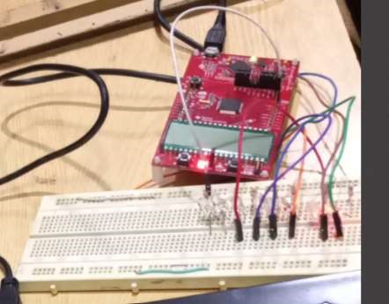

**TASK2:**

**write a program which monitor a switch if it is not pressed then toggle LED attach with P1.0 if it is pressed then stop toggling.**

**#include <msp430.h>**

**CODE:**

*#include <msp430.h>*

*int main(void) {*

*WDTCTL = WDTPW | WDTHOLD; // Stop watchdog timer*

*PM5CTL0 &= ~LOCKLPM5; // Enable GPIOs*

*P1DIR |= 0x01; // Set P1.0 as output (LED)*

*P1DIR &= ~0x04; // Set P1.2 as input (Switch)*

*P1OUT |= 0x04; // Pull-up resistor on P1.2*

*P1REN |= 0x04; // Enable resistor on P1.2*

*while(1) {*

*if (P1IN & 0x04) { // If switch is NOT pressed mean P1.2 will high*

*P1OUT ^= 0x01; // Toggle LED on P1.0*

*__delay_cycles(100000); // Toggle speed*

*}*

*}*

*}*

**OUTPUT:**

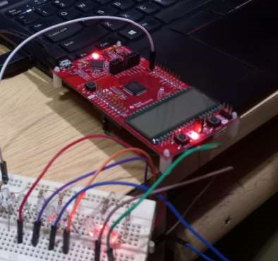

**TASK3:**

**write a program which monitor a switch if the switch is pressed the LED if on should off and if off should ON.**

**CODE:**

*int main(void) {*

*WDTCTL = WDTPW | WDTHOLD; // Stop watchdog timer*

*PM5CTL0 &= ~LOCKLPM5; // Enable GPIOs*

*P1DIR |= 0x01; // Set P1.0 as output (LED)*

*P1DIR &= ~0x04; // Set P1.2 as input (Switch)*

*P1OUT |= 0x04; // Pull-up resistor on P1.2*

*P1REN |= 0x04; // Enable resistor on P1.2*

*while(1) {*

*if (!(P1IN & 0x04)) { // If switch is pressed*

*P1OUT ^= 0x01; // Toggle LED on P1.0*

*while (!(P1IN & 0x04)); // Wait for switch release*

*__delay_cycles(100000); // Debounce delay*

*}*

*}*

*}*

**OUTPUT:**

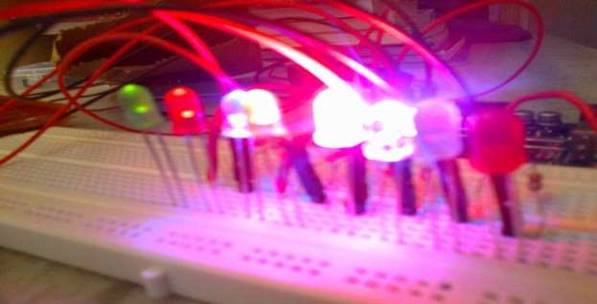

**TASK4:**

**Write a program which monitors a switch. If it is not pressed, then toggle the LED attached with P1.0. If it is pressed, then stop toggling.**

**CODE:**

*#include <msp430.h>*

*int main(void) {*

*WDTCTL = WDTPW | WDTHOLD; // Stop watchdog timer*

*PM5CTL0 &= ~LOCKLPM5; // Enable GPIOs*

*P1DIR |= 0x01; // Set P1.0 as output (LED)*

*P1DIR &= ~0x04; // Set P1.2 as input (Switch)*

*P1OUT |= 0x04; // Pull-up resistor on P1.2*

*P1REN |= 0x04; // Enable resistor on P1.2*

*while(1) {*

*if (P1IN & 0x04) { // If switch is NOT pressed*

*P1OUT ^= 0x01; // Toggle LED on P1.0*

*__delay_cycles(100000);*

*}*

*// If the switch is pressed, do nothing (stop toggling)*

*}*

*}*

**OUTPUT:**

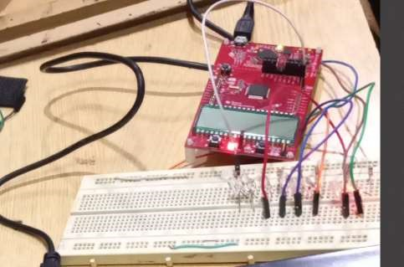

**Task 05:**

**NIGHT RIDER CODE:**

#include <msp430.h>

int main(void) {

WDTCTL = WDTPW | WDTHOLD; // Stop watchdog timer

PM5CTL0 &= ~LOCKLPM5;

P8DIR |= 0xFF; // Set all 8 pins of Port 8 as output

P1DIR &= ~0x04; // Set P1.2 as input (Switch)

P8OUT = 0x00; // Start with all LEDs off

P1REN |= 0x04; // Enable pull-up resistor on P1.2

P1OUT |= 0x04; // Pull-up resistor active

unsigned char pattern = 0x01; // Start with the first LED

while (1) {

if (!(P1IN & 0x04)) { // If switch is pressed

__delay_cycles(100000); // Debounce delay

P8OUT = pattern; // Turn on current LED

__delay_cycles(100000); // Blink delay

P8OUT = 0x00; // Turn off all LEDs __delay_cycles(100000); // Off delay pattern <<= 1; // Shift pattern to the next LED

if (pattern == 0x00) { // If pattern goes beyond P8.7 pattern = 0x01; // Reset to the first LED

}

} else {

P8OUT = 0x00; // Turn off all LEDs when switch is not pressed

}

}

return 0;

}

**Output:**

